Name: Sialas Tripp Mark _____________________/50

## Brief introduction __/3

I will be making the basic movement and controls for the player tank, along with porting the final build to mobile devices, and designing and implementing all music and sound effects.

When it’s the player’s turn, they will control the tank by using their AP (action points) to choose between two actions: moving or shooting. To move the player’s tank, the player will click on an available tile that is within their movement range. If there is an item on the tile, when the player moves to its location, it will instantly activate and modify the player’s attributes. If the player decides to shoot, they will click on the enemy tank’s location. The game will then simulate a dice-roll to determine if the shot misses or hits the enemy.

Additionally, whenever the game is running, there will be some sort of music or sound effect playing. This will help set the appropriate tones and feeling of the game as well as enhance moments such as shooting or picking up items.

## Use case diagram with scenario __14

### Use Case Diagrams

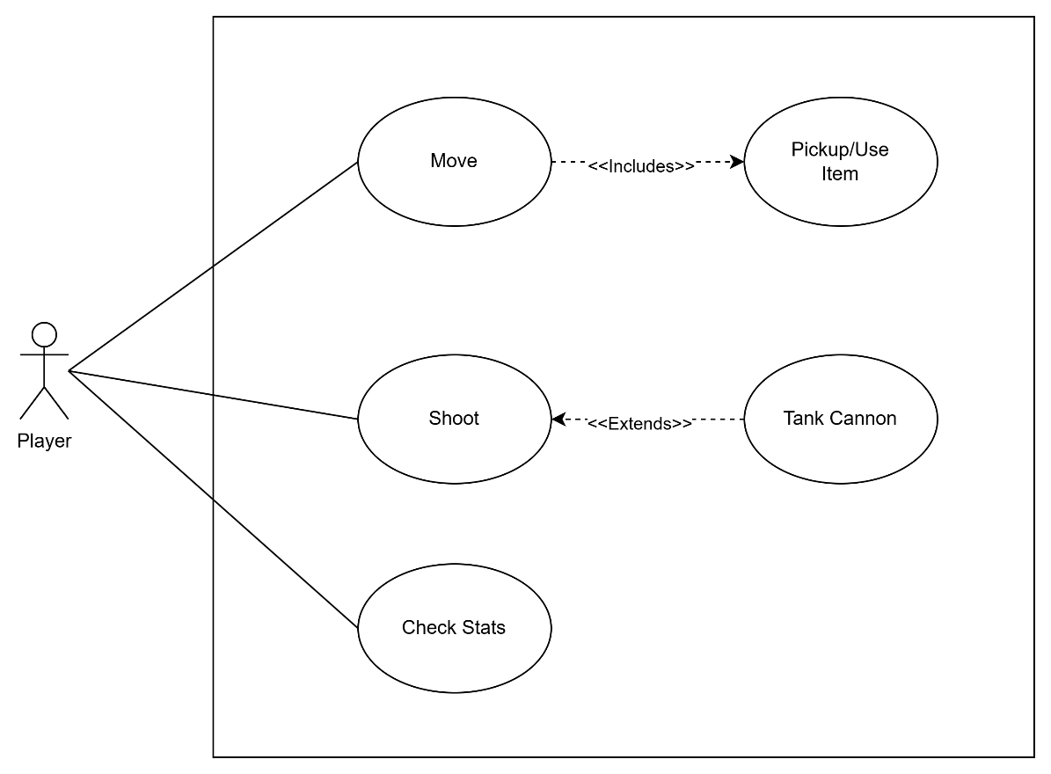

### Scenarios

**Name:** Shooting an Enemy Tank

**Summary:** The player makes an attack at an enemy tank.

**Actors:** The player

**Preconditions:** Game running and it is the player’s turn.

**Basic sequence:**

**Step 1:** Check to see if it’s player’s turn.

**Step 2:** Shoot at enemy.

**Step 3:** Check to see if shot hit.

**Step 4:** Update world.

**Exceptions:**

**Step 2.1:** If there isn’t an enemy on selected tile, then don’t do anything.

**Step 2.2:** If there is an enemy on selected tile, execute animation then check for step 3.

**Post conditions:** Calculated value is displayed.

**Priority:** 1*

**ID:** S01

*The priorities are 1 = must have, 2 = essential, 3 = nice to have.

## Data Flow diagram(s) from Level 0 to process description for your feature _______14

[Get the Level 0 from your team. Highlight the path to your feature]

Example:

### Data Flow Diagrams

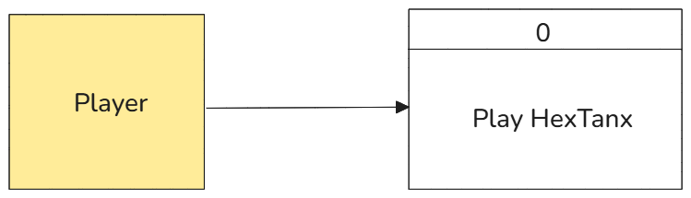

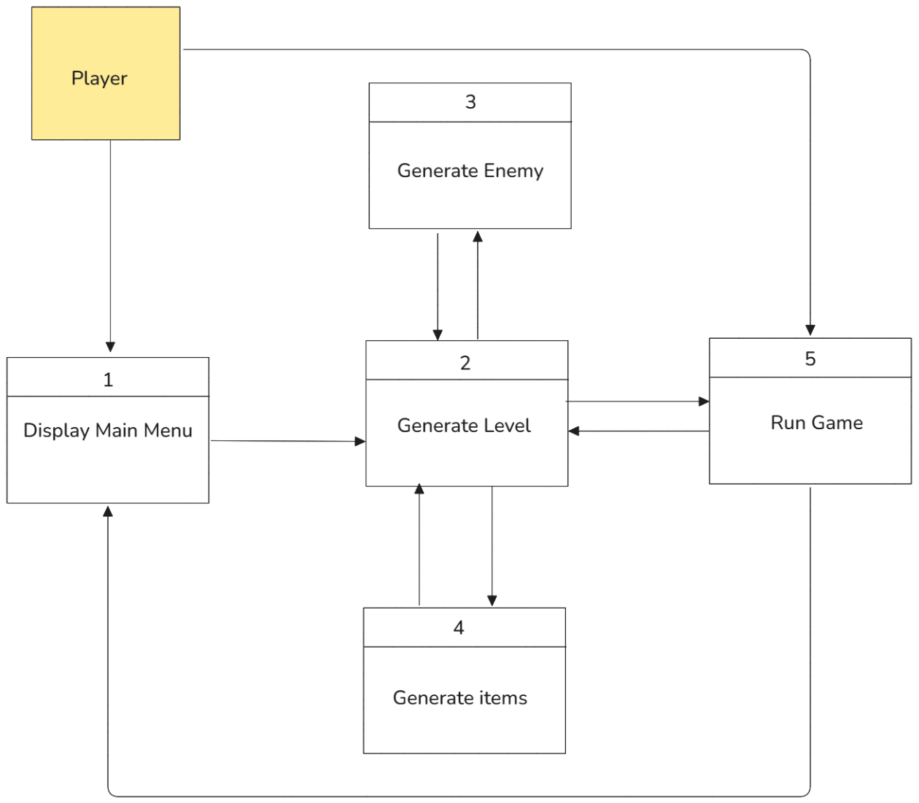

### Process Descriptions

if player shoots then

check if shot fired hit

if shot hits then

execute shot hit animations

update game world

else if shot fired misses then

execute shot missed animations

update game world

else

do nothing

endif

endif

## Acceptance Tests ________9

Test will check player input to see if actions are properly executed only under the correct circumstances on the correct targets. These actions include:

* Shooting attacks
* Moving to a new tile
* Picking up instant use items on the map
* Instant use items properly affect player stats (i.e health, movement distance, action points, shooting damage)
* Picking up the enemy flag
* Enemy attacks properly damage the player.

The output file will contain:

* “Dice rolls” to determine if shot hits
* Tile coordinates of enemy tank and tile you selected to shoot at
* Enemy tank’s health before/after being shot
* Tile coordinates of location before/after the player moved
* Name of item picked up/location of item
* Stats of player before/after item was picked up/used
* Status of flag
* Stats of the player before/after being shot by enemy tank

## Timeline _________/10

### Work items

|  |  |  |
| --- | --- | --- |
| Task | Duration (PWks) | Predecessor Task(s) |
| 1. Design Movement | 5 | - |
| 2. Design Shooting | 4 | - |
| 3. Research/design sound assets | 2 | - |
| 4. Programming sound | 4 | 3 |
| 5. Programming movement | 6 | 1 |
| 6. Programming shooting | 6 | 2 |
| 7. Documentation | 4 | 4,5,6 |
| 8. Testing | 3 | 4,5,6 |
| 9. Installation | 1 | 8 |

### Pert diagram

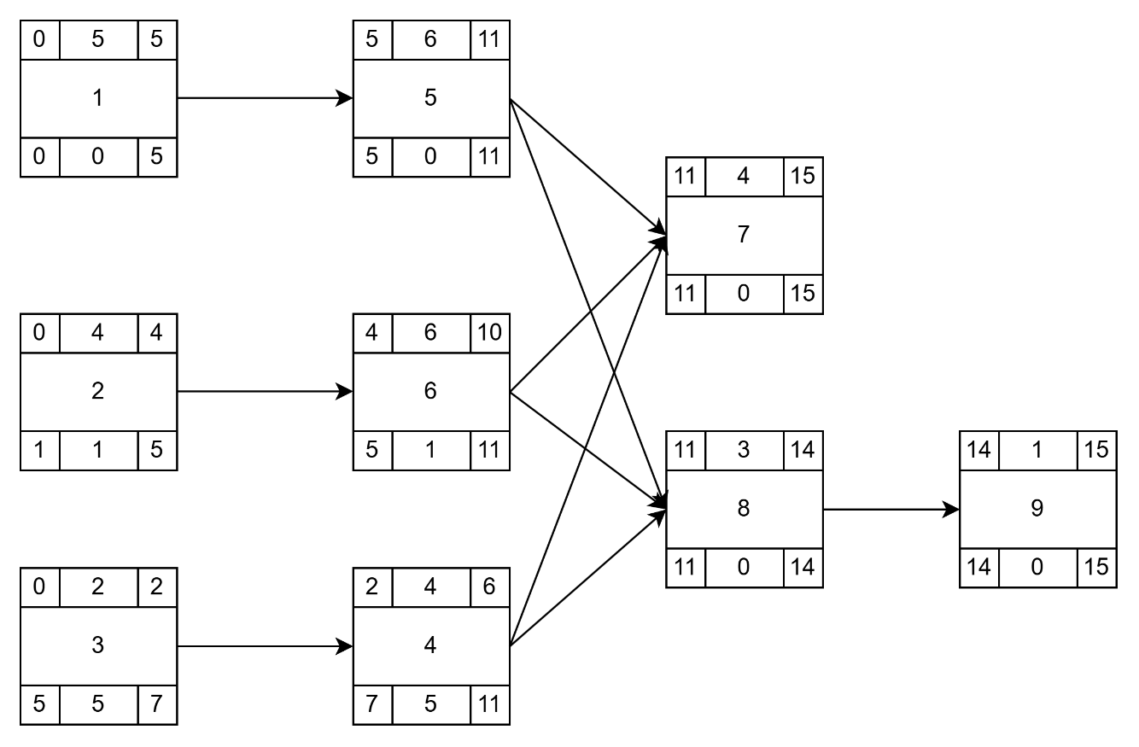

### Gantt timeline

|  |  |  |  |  |  |  |  |  |  |  |  |  |  |  |  |
| --- | --- | --- | --- | --- | --- | --- | --- | --- | --- | --- | --- | --- | --- | --- | --- |
| 1 |  |  |  |  |  |  |  |  |  |  |  |  |  |  |  |
| 2 |  |  |  |  |  |  |  |  |  |  |  |  |  |  |  |
| 3 |  |  |  |  |  |  |  |  |  |  |  |  |  |  |  |
| 4 |  |  | 3 |  |  |  |  |  |  |  |  |  |  |  |  |
| 5 |  |  |  |  |  | 1 |  |  |  |  |  |  |  |  |  |
| 6 |  |  |  |  | 2 |  |  |  |  |  |  |  |  |  |  |
| 7 |  |  |  |  |  |  |  |  |  |  |  | 4,5,6 |  |  |  |
| 8 |  |  |  |  |  |  |  |  |  |  |  | 4,5,6 |  |  |  |
| 9 |  |  |  |  |  |  |  |  |  |  |  |  |  |  | 8 |
|  | 1 | 2 | 3 | 4 | 5 | 6 | 7 | 8 | 9 | 10 | 11 | 12 | 13 | 14 | 15 |